**Creating and Monitoring tripwires: Honey pots**

Local security policies

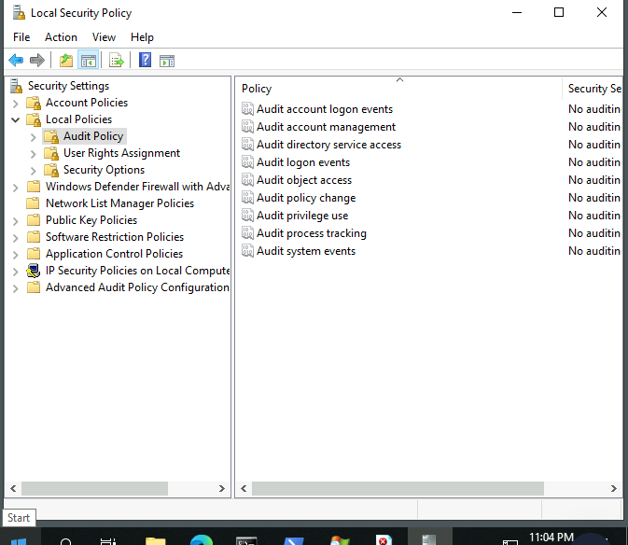

Apply changes to audit object access. This entails that all access attempts will be logged, regardless of whether it succeeded

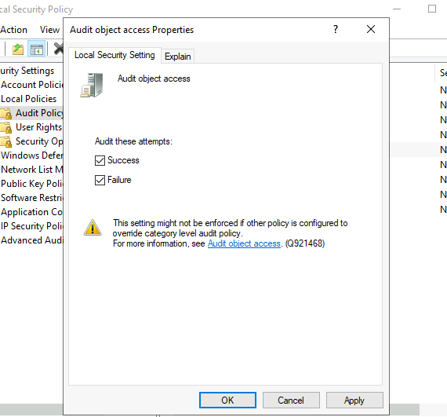

Setting up a new doc and make a tripwire

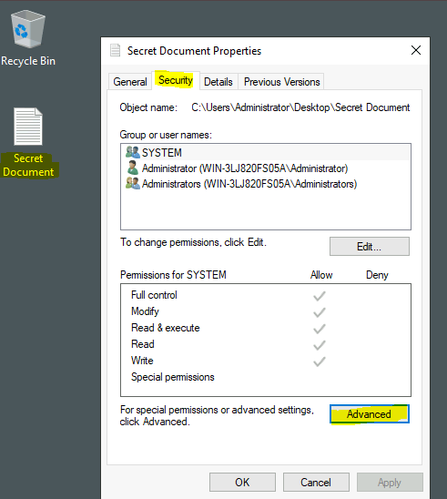

Auditing settings: principal object is everyone

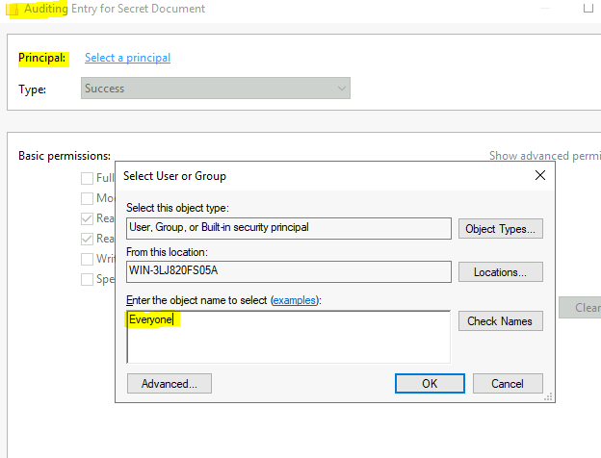

Advanced permissions for everyone accessing the file

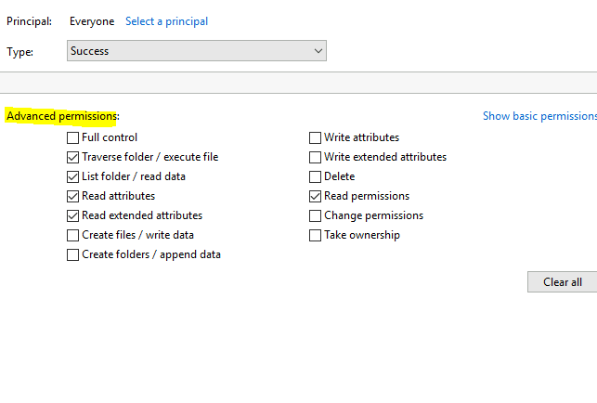

Effective access

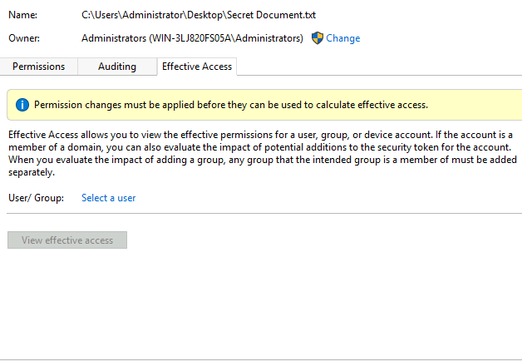

Reading the file logs in full event logs

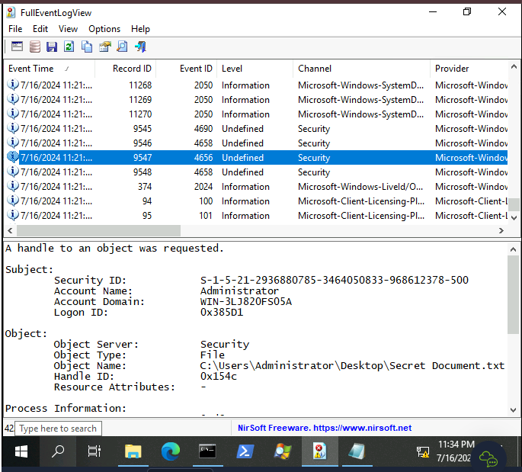

Eventid 4658- closing of object

